* Design TM using simulator to perform subtraction of aaa-aa

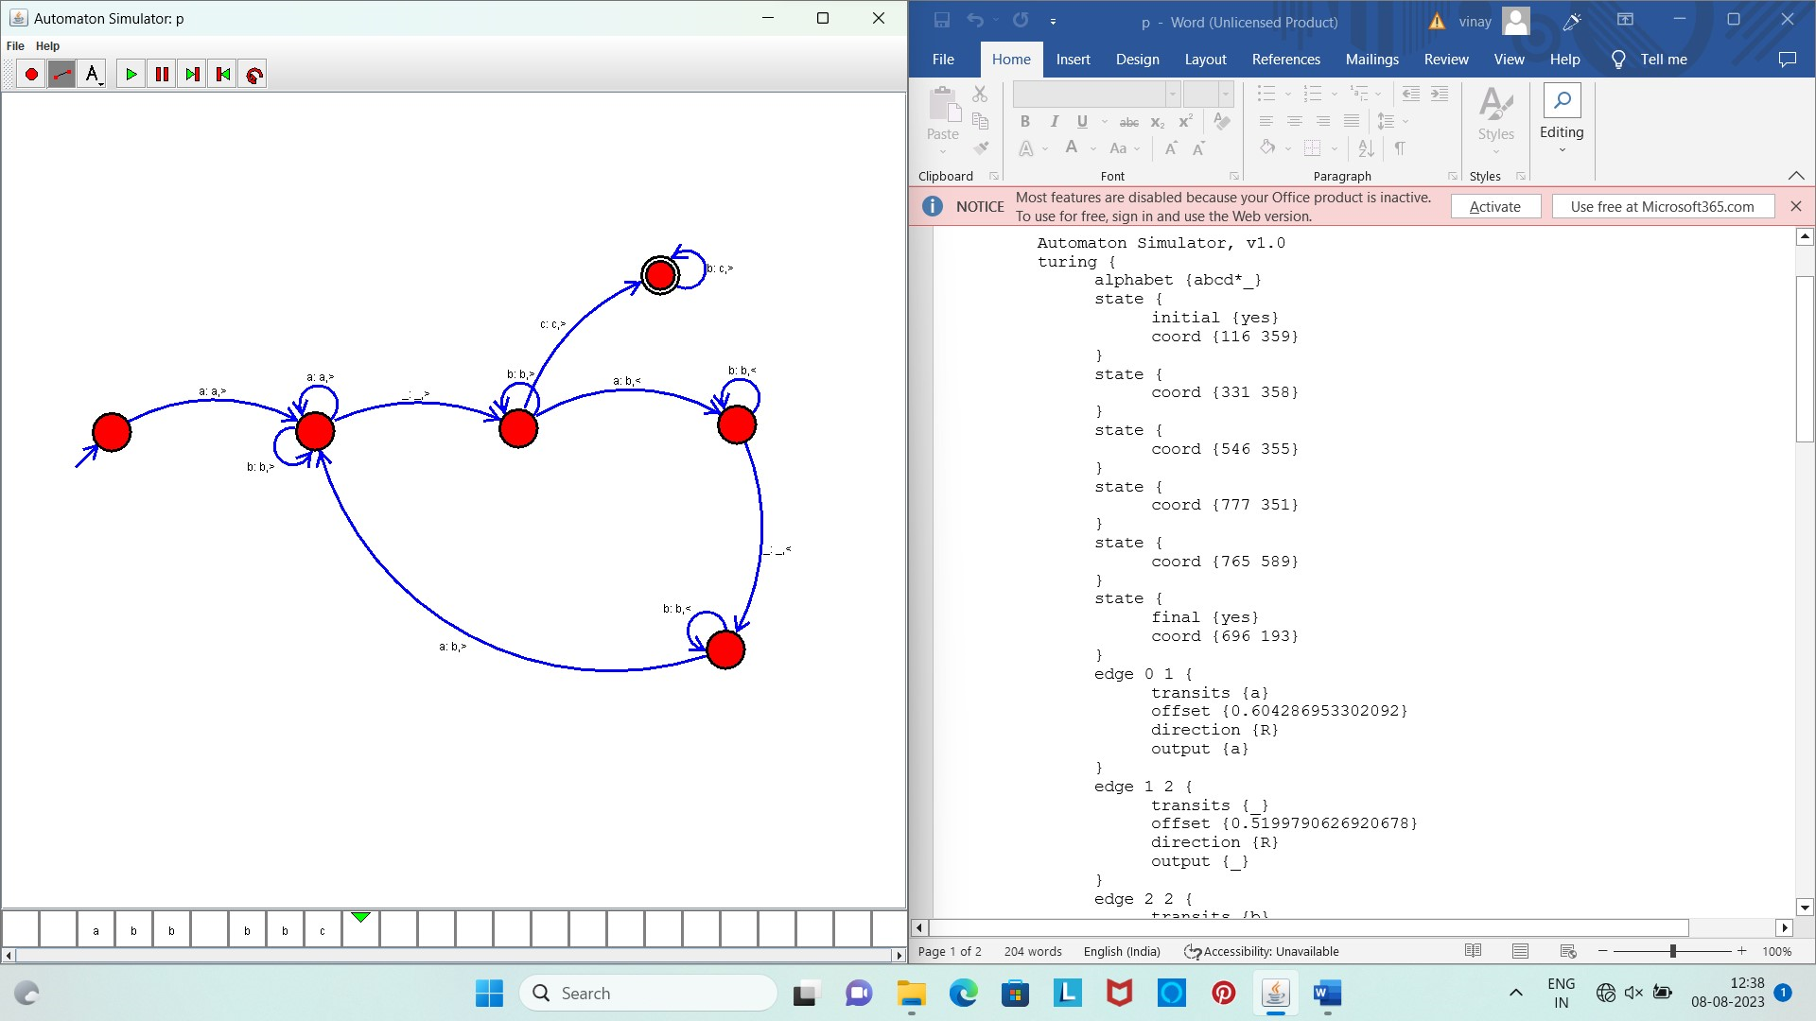

Result :

The simulator is accepted the performance of subtraction of aaa-aa by using the above TM diagram